Pan Tilt Mechanism

Assembling the pan-tilt rig is tedious. As such, take your time and read the instructions carefully. Be mindful of the materials you are working with as well - using too much torque or force when tightening screws or fitting parts together can result in broken parts. On a final note, take extra care to make sure the servos are aligned correctly when mounting them.
The parts included in pan-tilt kit are shown in the figure below.
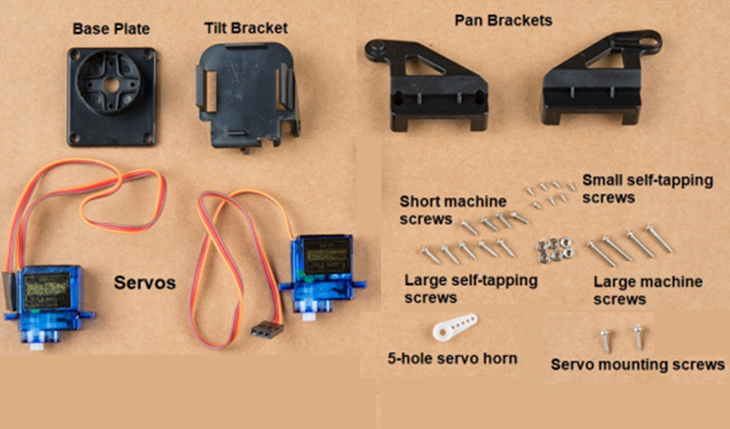

First, identify the larger self-tapping screws. These will be used for assembling the bottom part of the mechanism or the "Pan" part.
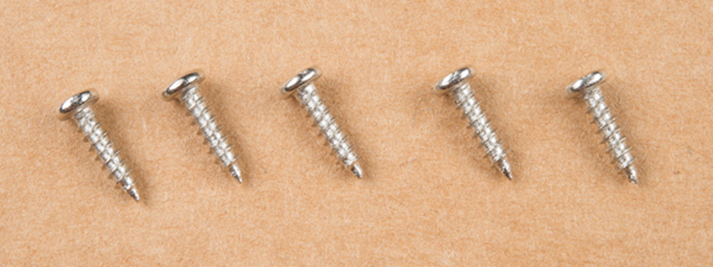

Find the Pan Brackets - these are the two brackets that sandwich together. Place one of the servos in the center and connect the two brackets. Take note of the orientation of the servo in the brackets below as it's important.
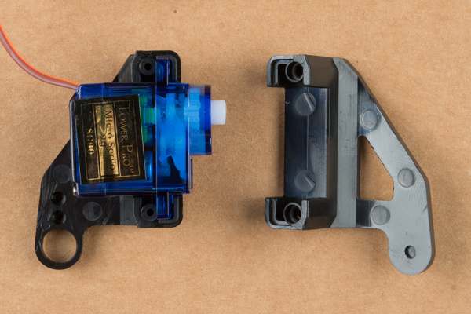

Here are the brackets together. Try to make sure the servo is centered.
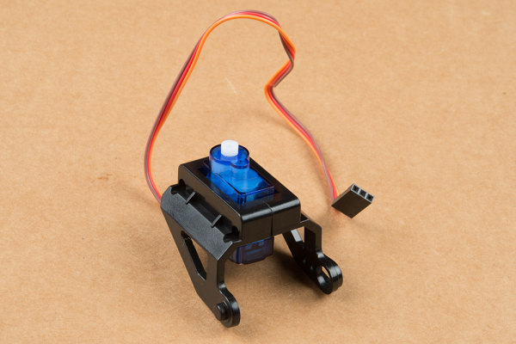

Take the larger self-tapping screws and affix the two brackets together like in the image below. Take extra care not to over-torque the screws and damage the plastic.
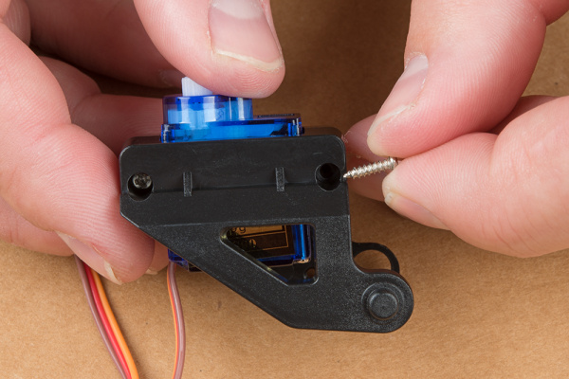

You'll now need the single arm servo horn with a single hole (Note: arm shown below has 5 holes and differs from the one in your kit), as shown in the image below.
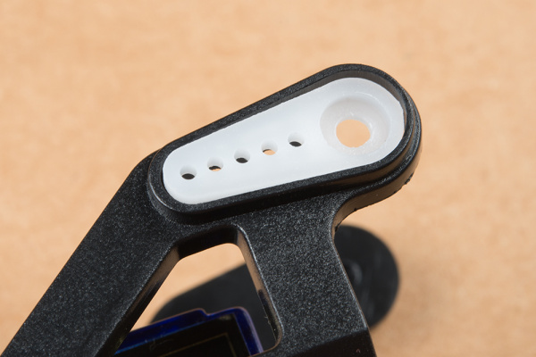

Install the single arm servo horn as shown below. You'll need two of the small self-tapping screws to affix it to the mechanism.
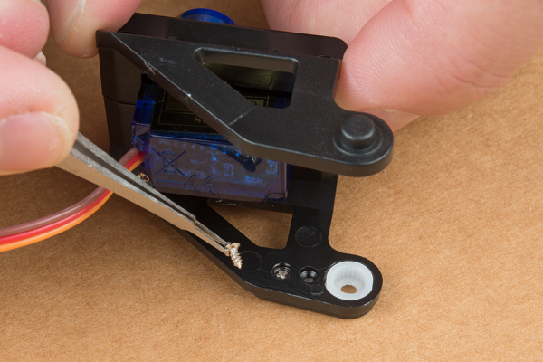

Next, you'll need the second servo motor and the Tilt Bracket.
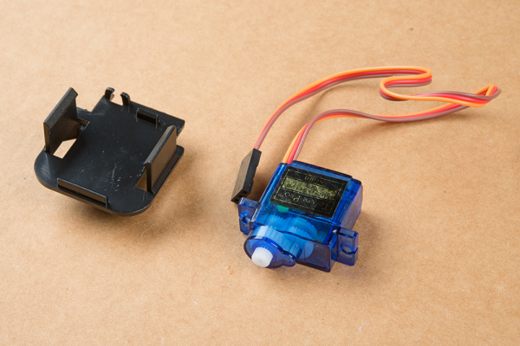

The image below shows the relative orientation of these two pieces:
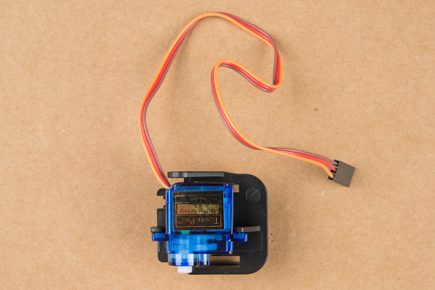
Now, find the longest machine screws in the bag, as shown below. You may find that there are more of these than you need.
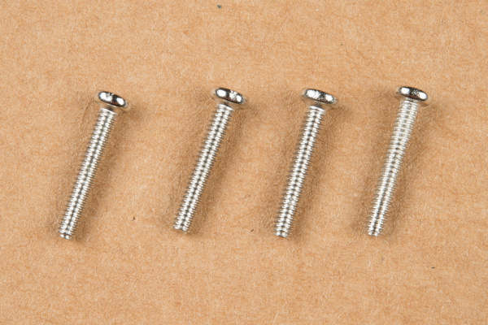
Thread these screws through the stand off wings on the servo motor and into the last piece of the mechanism. You can use nuts for these if you like, but I've found it to be unnecessary as they thread into the mechanism quite snugly without the nut.
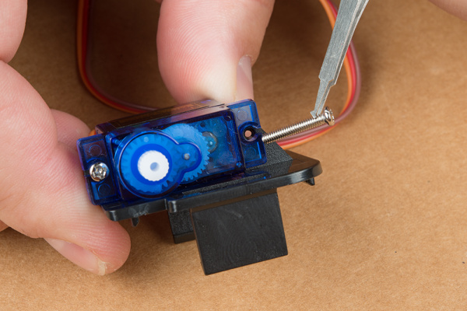

Now connect the two major pieces of the assembly together. The image below shows the orientation of these two parts. You may need to assemble and disassemble these two parts a couple of times to find the right rotational position of the servo motor so that the tilting portion has its full range of motion. Do this by connecting the two parts and carefully turning the "Tilt" servo back and forth until it's able to get the most unobstructed range while the mid-point of this range falls when the two servos are perpendicular to each other.
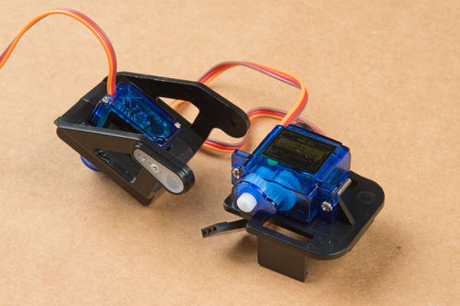

Here's an image of what it should look like with the two mechanisms attached. Note: you may need to place a small amount of glue in the servo horn when attaching the servo to keep the servo from turning in the horn. If you use glue ensure the glue does not seep out of the servo socket and keep the mechanims from turning.
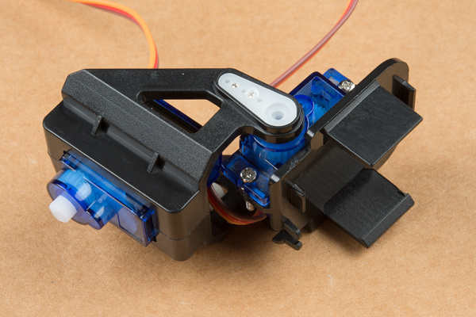
Sometimes the pan and tilt parts won't line up evenly. if this is the case, add a nut (provided in the bag) between the servo and the plastic part of the tilt mechanism as shown below.
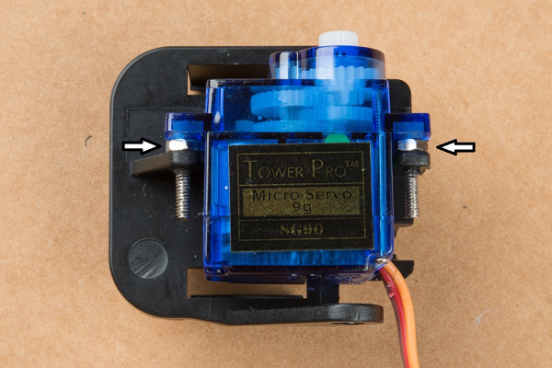

Take the final screw that you identified above as a horn attaching screw and use it to secure the horn to the servo motor. You do NOT need much torque here - be very gentle!
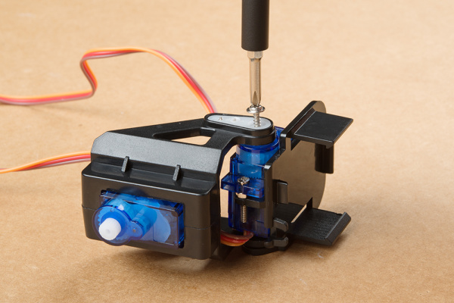

Now, let’s focus on assembling the base of the tilt pan assembly. Start by finding the servo arm that fits into the base of the pan assembly (The one in your kit was printed with a 3-D printer and only has a single hole in each of the four arms). The two components are shown below:
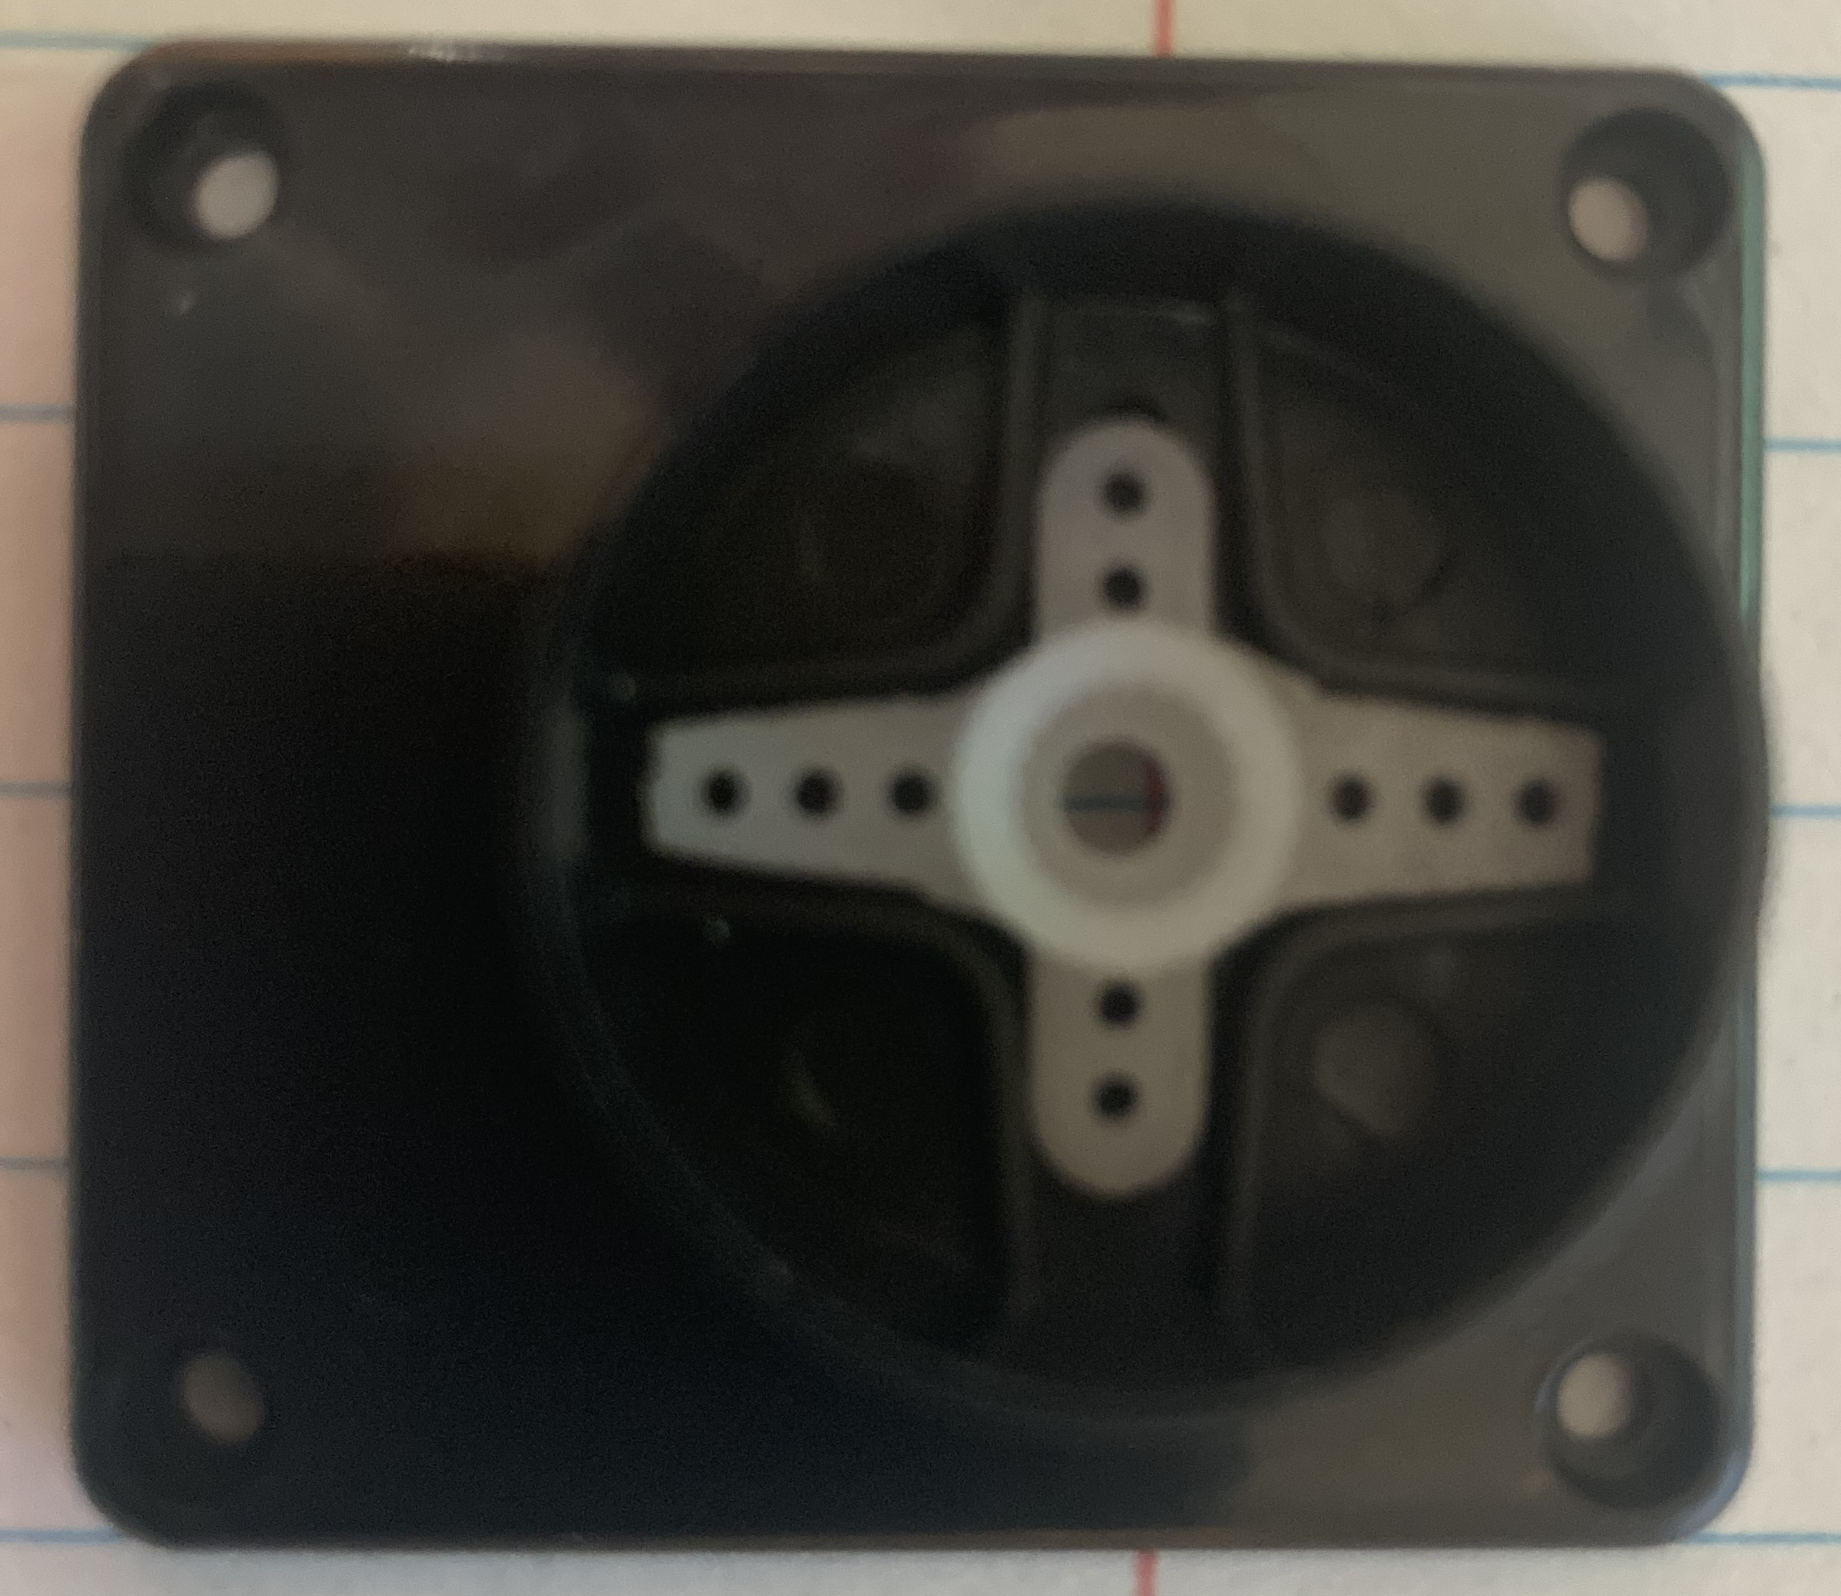

Once you have placed the servo arm in the base of the pan assembly use two of the small screws in your kit to attach the servo arm to the base. The screws must be inserted into the long arms versus the short arms. In addition, the holes may not line up exactly. As such, you should get each screw partially started before tightening either screw. A graphic of the screws and the assembly are shown below:
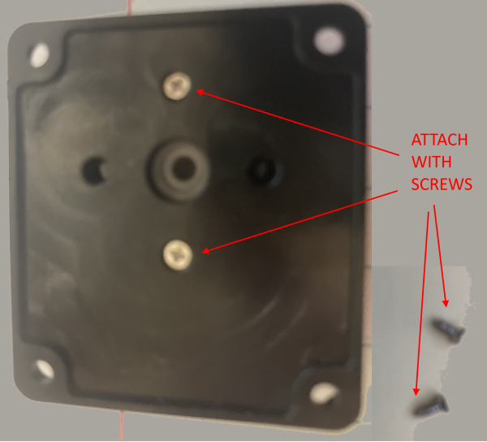
Once you have the servo attached to the pan assembly base, attach the lower servo you previously attached to the pan assembly to the base using one of the supplied screws. Note: you may need to place a small amount of glue in the servo horn when attaching the servo to keep the servo from turning in the horn. If you use glue ensure the glue does not seep out of the servo socket and keep the mechanims from turning.
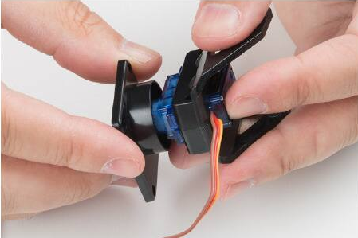
Once the servo is in place, use a screw to attach the base to the servo (see below):
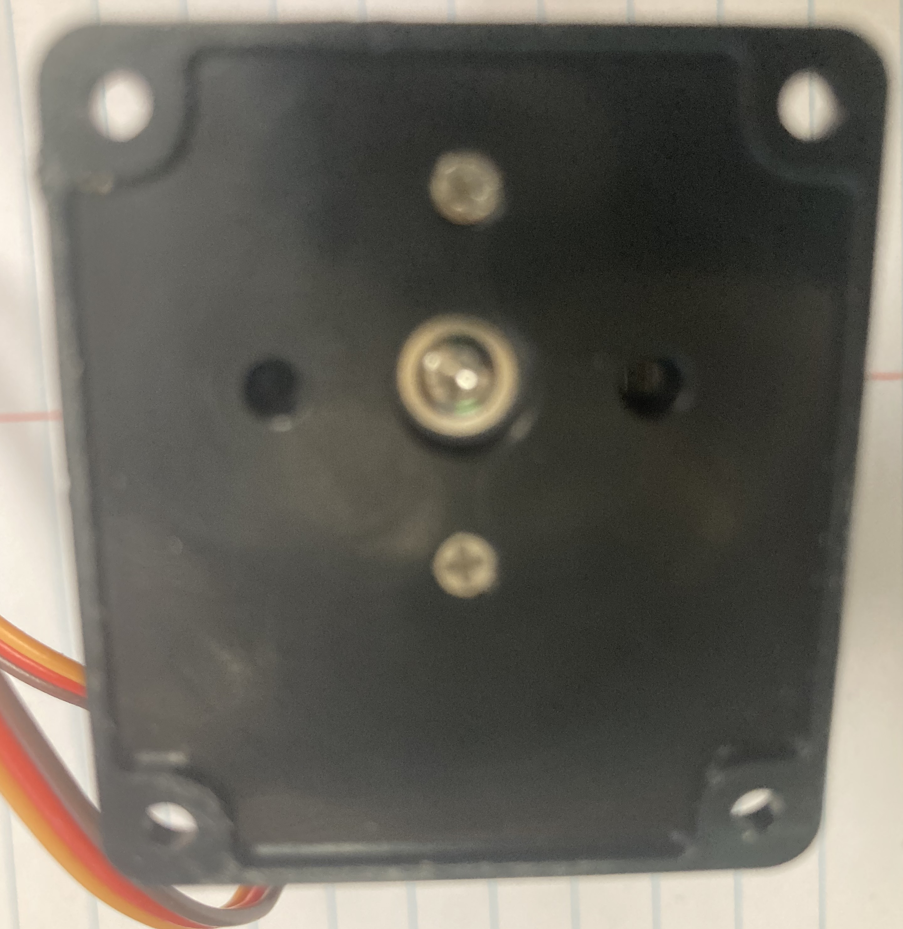

At this point you have completed the assembly of the pan tilt assembly. You can now move on to writing code to manipulate the servos.

